Gloss Colors
Granite Colors
Alabaster
Amethyst
Bamboo
Blizzard
Blue Pearl
Bronzite
Cadet
Cameo
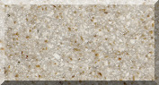
Cappuchino
Caramel
Carrara
Cashmere
Chestnut
Cloud
Coconut
Constellation
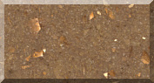
Corinthian
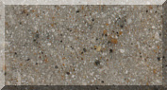
Dolphin
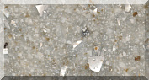
Dorian
Dove
Driftwood
Fashion
Flannel
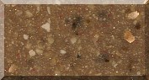
Florentine
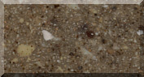
Granada
Gray Pearl
Gun Metal
Iceberg
Icicle
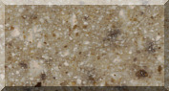
Journey
Keystone
LowTide
Moonstone
Mystique
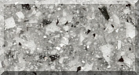
Pepper
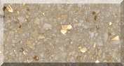
Prospect
Rosalie
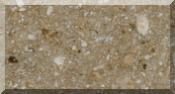
Safari
Sandstone
Sedona
Serenity
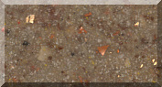
Sierra
Silver
Spice
Summer
Tiger Eye
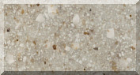
Tiramisu
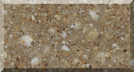
Tumbleweed
Walnut

Snowswirl, & Solid Colors
Snowswirl
Biscuit
Bone
White Onyx

