Matte Colors
Granite, Snowswirl, & Solid Colors
Alabaster
Bamboo
Blizzard
Carrara
Cloud
Coconut
Dove
Iceberg
Icicle
LowTide
Moonstone
Sandstone
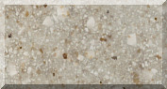
Tiramisu
White Onyx

